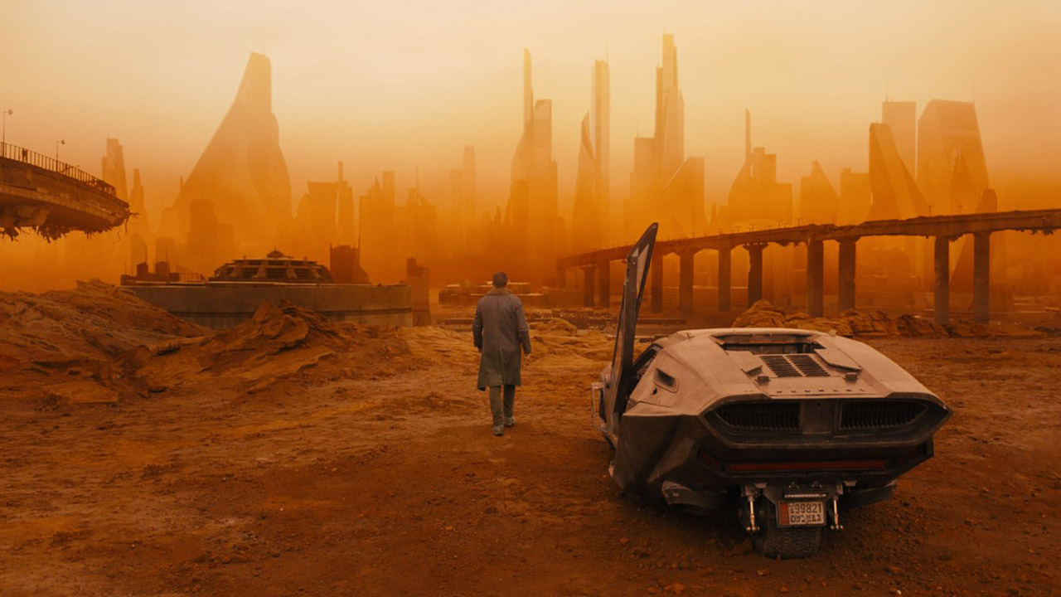



**Blade Runner 2049**

Begleitmaterial für den Unterricht   
von FILM+SCHULE NRW





**Impressum**

**Herausgeber**

FILM+SCHULE NRW

LWL-Medienzentrum für Westfalen

Fürstenbergstraße 13-15

48147 Münster

**Autoren**

Ann Kristin vom Ort  
Wissenschaftliche Referentin FILM+SCHULE NRW

Michael Cremann  
Studentischer Volontär SchulKinoWochen NRW

Jannik Arne Beckmann (englische Übersetzung)

Praktikant FILM+SCHULE NRW

**Redaktion**

Uwe LeonhardtGeschäftsführer FILM+SCHULE NRW

Jelka Luckfiel

Pädagogische Referentin FILM+SCHULE NRW

**Gestaltung**

Ann Kristin vom Ort

Wissenschaftliche Referentin FILM+SCHULE NRW

Melina Jasmine Kalwey  
Studentische Volontärin FILM+SCHULE NRW

**Foto Titelseite** © media-versand

Das gesamte Material unterliegt folgenden Lizenzbedingungen:

FILM+SCHULE NRW ist eine gemeinsame Initiative des Ministeriums für Schule und Bildung des Landes Nordrhein-Westfalen und des LWL-Medienzentrums für Westfalen.





**The Opening**

1. Watch the opening scene (00:00:46-00:03:21) of Blade Runner 2049 and work on the following tasks.
2. Take brief notes of the information given through text and visuals within the first minutes of the movie.
3. Describe your impression of Los Angeles in the year 2049. Answer in brief notes and give reasons.
4. How would you describe the relationship between man and nature? Next to the matching picture, write down the different aspects of the themes you can identify.

|  |  |
| --- | --- |
| **Film stills** | **Aspects of themes** |
| V:\Film_und_Schule\Unterrichtsmaterial+Tools\Ausgezeichnet!\Unterrichtsmaterial\Ausgezeichnet!_Arbeitsblattsets\Blade_Runner_2049\Bildmaterial\Mensch_Umwelt1.jpg |  |
| V:\Film_und_Schule\Unterrichtsmaterial+Tools\Ausgezeichnet!\Unterrichtsmaterial\Ausgezeichnet!_Arbeitsblattsets\Blade_Runner_2049\Bildmaterial\Mensch_Umwelt2.jpg |  |
| V:\Film_und_Schule\Unterrichtsmaterial+Tools\Ausgezeichnet!\Unterrichtsmaterial\Ausgezeichnet!_Arbeitsblattsets\Blade_Runner_2049\Bildmaterial\Mensch_Umwelt3.jpg |  |

1. The following tasks will revolve around dramatic structure. Read the infobox on the topic of exposition and answer the following questions.
2. Is the exposition of Blade Runner 2049 inductive or deductive?
3. What function does the opening serve regarding the dramatic structure? Give a written response and consider your results from Task 1.
4. What are your expectations toward the movie and its plot, judging by the opening scene? Working with a partner/partners, create a mindmap in which you gather potential themes of the movie Blade Runner 2049, based on the opening scene.

**Info**



**Deductive Exposition**

In a deductive exposition, the viewer enters the scene from a distance. Wide shots give a general overview of the setting and situation, before the characters and events are examined closer. Deductive exposition is very common.

**Inductive Exposition**

Inductive exposition works the other way around. A close-up look at characters or events is followed by a more removed shot or general overview of the setting.

**Field Sizes and Camera Angles**

Blade Runner and LAPD-Officer K is searching for the protein farmer and replicant Sapper Morton to “retire” him. The film-clip with the timecode 00:03:31-00:06:26 shows the confrontation of the two protagonists.

1. Carefully watch the film-clip.

1. What is your initial impression of Sapper Morton and why?
2. Open the app “TopShot” and explore the categories “field sizes” and “camera angles” for different types of visual framing. Use the info-button to learn more about the respective functions of these cinematic devices.
3. The film stills in the table on the next page are taken from that clip. Carefully examine the pictures and work on the following tasks.
4. Use the app “TopShot” to enter the field sizes into the right column of the table below and explain its effect.
5. Enter the camera angles into the right column and write down their effect. You may use “TopShot” as a reference again.
6. Compare your results with a partner and complete your list if necessary.
7. The film stills in the table are in the same order as they appear in the scene. Why is this specific order meaningful with regard to the field sizes that were chosen and what is the narrative goal?

Take your results from task 1 as a starting point and discuss with a partner. Document your results in brief notes.

1. What information does the scene reveal about Sapper Morton and how does it support the notion that he is a “replicant” (who needs to be retired)? Give a written response.

|  |  |
| --- | --- |
| **Film stills** | **Notes for a) & b)** |
| V:\Film_und_Schule\Unterrichtsmaterial+Tools\TabulaRasa_TabulaGo\Arbeitsblätter\Blade Runner 2049\Material bearbeitet\Einstellungsgrößen & Kameraperspektiven\Weit.jpg |  |
| V:\Film_und_Schule\Unterrichtsmaterial+Tools\TabulaRasa_TabulaGo\Arbeitsblätter\Blade Runner 2049\Material bearbeitet\Einstellungsgrößen & Kameraperspektiven\Nah1.jpg |  |
| V:\Film_und_Schule\Unterrichtsmaterial+Tools\TabulaRasa_TabulaGo\Arbeitsblätter\Blade Runner 2049\Material bearbeitet\Einstellungsgrößen & Kameraperspektiven\Halbtotale.jpg |  |
| V:\Film_und_Schule\Unterrichtsmaterial+Tools\TabulaRasa_TabulaGo\Arbeitsblätter\Blade Runner 2049\Material bearbeitet\Einstellungsgrößen & Kameraperspektiven\Groß.jpg |  |

**Staging of Character – Officer K**

After his day at work, K returns to his apartment. Watch the film-clip with the timecode 00:15:40-00:19:26 and work on the following tasks.

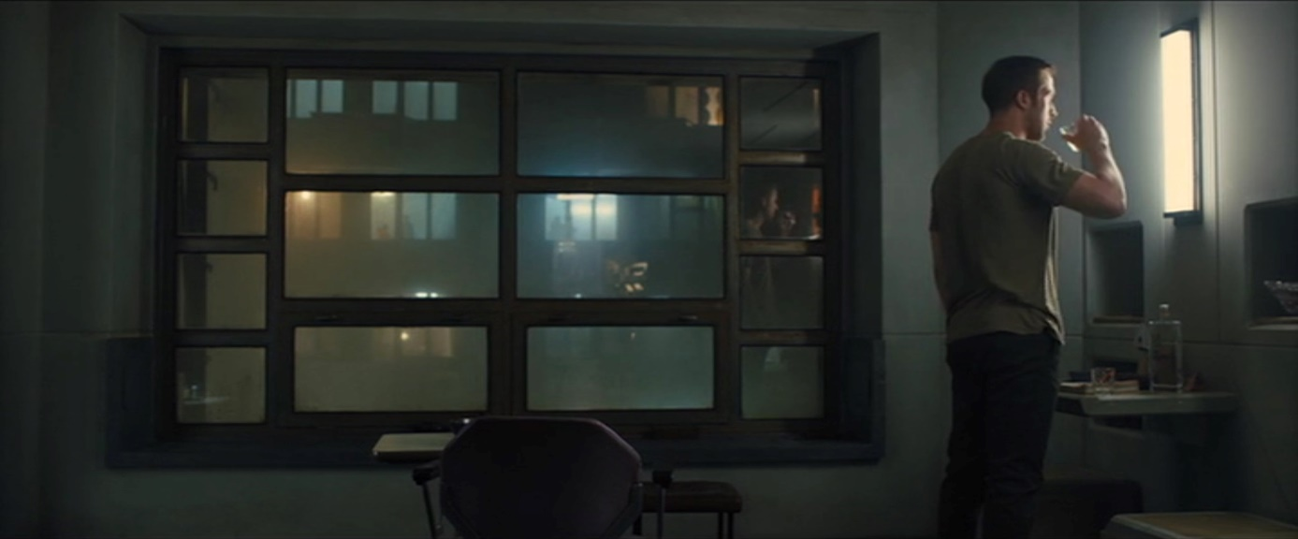

1. What is your impression of K? In 2-3 sentences, describe your initial thoughts and which character traits you would attribute to him.
2. Watch the clip a second time and pay close attention to how costume and props support your impression of him. Choose an item or a piece of clothing that you think supports the characterization of K. Write down which item you chose and briefly outline its function for the staging of the Character K.
3. The film still above shows K in his apartment.
4. Examine the geometric lines and shapes in the still by re-drawing them onto the image and highlighting the ones that stand out to you.
5. Now shift your focus to the color scheme of the picture. Mark prominent objects/color pallets and consider their symbolic meaning for the portrayal of K.
6. Compile a written characterization of officer K.

**Staging of Character – Niander Wallace**

Niander Wallace examines a new replicant model, fresh out of production. Watch the film-clip with the timecode 00:35:39-00:41:04 and work on the following tasks.

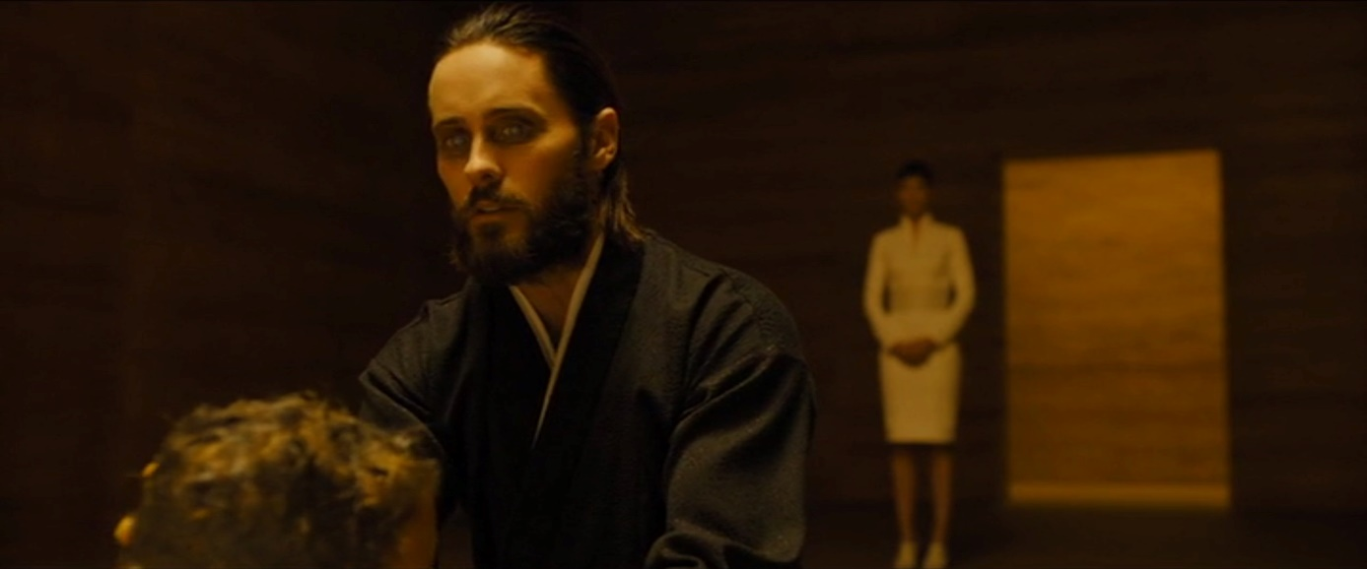

1. What is your impression of Niander Wallace? In 2-3 sentences, describe your initial thoughts and which character traits you would attribute to him.
2. Watch the clip a second time and pay close attention to how costume and props support your impression of him. Choose an item or a piece of clothing that you think supports the characterization of Wallace. Write down which item you chose and briefly outline its function for the staging of Niander Wallace.
3. The film still shows Niander Wallace during the examination of a new replicant.
4. Examine the geometric lines and shapes in the still by re-drawing them onto the image and highlighting the ones that stand out to you.
5. Now shift your focus to the color scheme of the picture. Mark prominent objects/color pallets and consider their symbolic meaning for the portrayal of K.
6. Compile a written characterization of Niander Wallace.

**Character Relationships – K & Joi**

The film excerpt (00:15:40-00:19:26) should already be familiar from the worksheet on staging officer K. K returns home after his day at work where Joi is already waiting for him.

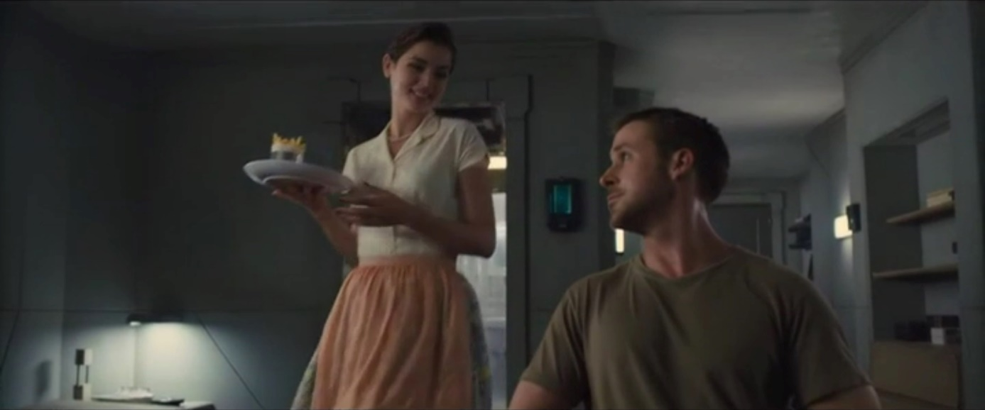

1. Carefully examine the film excerpt again and pay close attention to Joi. Give brief answers to the following questions in full sentences.
2. What is your impression of Joi?
3. What effect did the revelation that Joi is an artificial intelligence have on you?
4. Why could the viewer initially assume that Joi is a real woman and what could be the function of this introduction within the context of the scene?
5. Over the course of the scene, Joi frequently changes her looks and thereby embodies different female gender roles.
6. Take a look at the film stills from this scene in the table on the next page. Which female gender roles does Joi embody? Find appropriate terms for these roles and match them with their respective film stills. Add the role’s characteristics in brief notes.
7. Why does Joi alter her appearance like that? Write down a short answer in full sentences.

|  |  |
| --- | --- |
| **Film still** | **Gender role** |
| V:\Film_und_Schule\Unterrichtsmaterial+Tools\Ausgezeichnet!\Unterrichtsmaterial\Ausgezeichnet!_Arbeitsblattsets\Blade_Runner_2049\Bildmaterial\Joi1.jpg |  |
| V:\Film_und_Schule\Unterrichtsmaterial+Tools\Ausgezeichnet!\Unterrichtsmaterial\Ausgezeichnet!_Arbeitsblattsets\Blade_Runner_2049\Bildmaterial\Joi2.jpg |  |
| V:\Film_und_Schule\Unterrichtsmaterial+Tools\Ausgezeichnet!\Unterrichtsmaterial\Ausgezeichnet!_Arbeitsblattsets\Blade_Runner_2049\Bildmaterial\Joi3.jpg |  |
| V:\Film_und_Schule\Unterrichtsmaterial+Tools\Ausgezeichnet!\Unterrichtsmaterial\Ausgezeichnet!_Arbeitsblattsets\Blade_Runner_2049\Bildmaterial\Joi4.jpg |  |

1. K has a gift for Joi.
2. How does K present his gift to Joi? Write down your observations and what the gesture reminds you of.
3. Give a brief written account of what this gift means for the relationship between K and Joi.
4. Right before K gives Joi the present, the following conversation takes place:

|  |  |
| --- | --- |
| Joi: | “What’s the occasion?” |
| K: | “Let’s just say… it’s our anniversary.” |
| Joi: | “Is it?” |
| K: | “No, but… let’s just say that it is. Okay? Happy anniversary.” |

What does this sequence of dialogue reveal and to what extend does it represent the relationship between K and Joi? Discuss with a partner and keep the results from the previous tasks in mind. Afterwards, write down your findings and reasoning.

1. Watch the film-clip with the timecode 02:11:06-02:12:19.

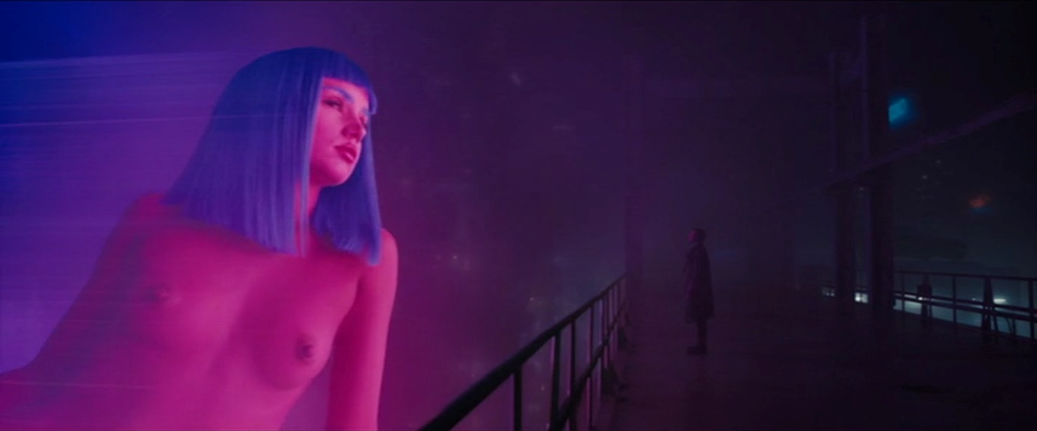

1. Write down Joi’s remarks and also the advertisement slogans.
2. Describe the hologram´s effect on you and explain which design choices evoke this effect.
3. What does K or “Joe” finally realize while observing the advertisement? What is the significance of this realization with regard to his relationship to Joi, who was destroyed prior to this scene? Write down your thoughts and support your analysis by referring to your notes from task a) and b).

**Color Symbolism & Use of Color to Create a “Leitmotif”**

1. The film Blade Runner 2049 prominently features the colors yellow, orange and blue. Which symbolic meanings can be attributed to these colors? Share your ideas with a partner.
2. The table on the next page lists some examples of film stills that show the utilization of the colors in the visual staging.
3. How do the different colors affect your impression of the film stills? Enter your thoughts into the table.
4. Different shots are being connected through the use of the colors blue, yellow and orange. What could be the overarching symbolic significance of these colors for the movie? What could they represent? Exchange your findings with a partner. Afterwards, write down your theories and include your findings for task 1.
5. Yellow/orange and blue are complementary colors (according to the traditional color model.) How does that affect your theories for an overarching significance of the use of color in task b)?
6. What purpose does the film still below serve with regard to the depiction of the relationship between replicants (artificial creation) and nature? Come up with theories by using your results of the previous tasks.

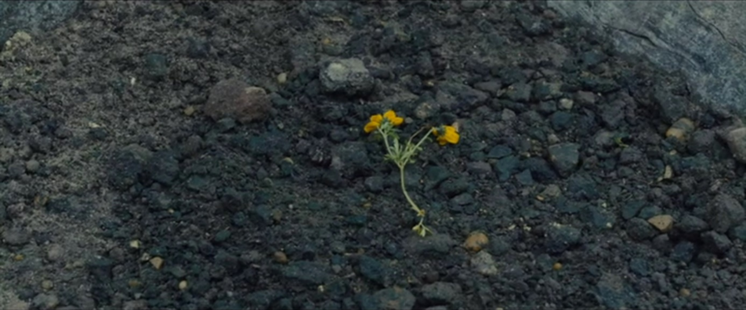

|  |  |
| --- | --- |
| **Film stills** | **Color & Effect** |
| V:\Film_und_Schule\Unterrichtsmaterial+Tools\TabulaRasa_TabulaGo\Arbeitsblätter\Blade Runner 2049\Material bearbeitet\Farben & Formen\Die_neue_Replkantin.jpg |  |
| V:\Film_und_Schule\Unterrichtsmaterial+Tools\TabulaRasa_TabulaGo\Arbeitsblätter\Blade Runner 2049\Material bearbeitet\Farben & Formen\Bienen_in_Las_Vegas.jpg |  |
| V:\Film_und_Schule\Unterrichtsmaterial+Tools\Ausgezeichnet!\Unterrichtsmaterial\Ausgezeichnet!_Arbeitsblattsets\Blade_Runner_2049\Bildmaterial\Blau1.jpg |  |
| V:\Film_und_Schule\Unterrichtsmaterial+Tools\Ausgezeichnet!\Unterrichtsmaterial\Ausgezeichnet!_Arbeitsblattsets\Blade_Runner_2049\Bildmaterial\Blau2.jpg |  |

**Humans vs. Replicants**

The world of Blade Runner 2049 is dictated by the ambivalent relationship between humans and replicants. In a key scene, corporate owner Niander Wallace examines a brand-new replicant model (00:35:39-00:41:04).

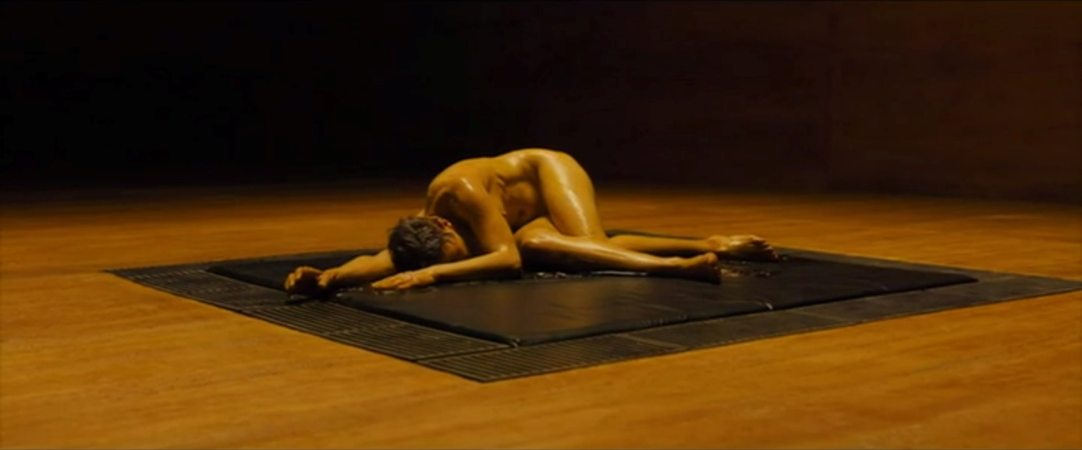

1. a) What is your impression of Niander Wallace and why?
2. What is your impression of the “new-born” replicant and why?
3. a) What does the visual imagery in the scene with the new-born replicant suggest

and what is its function within the context of the narrative?

1. Niander Wallace often refers to the bible in his monologue. Research the bible verses (if not already familiar) and interpret them in relation to Niander Wallace. Which conclusions can be drawn regarding Wallace’s character and the role he envisions for himself, his company and the replicants?
2. Which conclusions can you draw from your analysis of imagery and dialogue regarding the question if and how replicants differ from humans? Discuss with a partner and justify your responses by referring to specific aspects of the scene.
3. Why does Niander Wallace kill the newly-created replicant and which contradictions does his deed reveal? Compile a written interpretation.

**Cinematic Metaphors**

Certain objects, characters, settings or narratives can bear a strong symbolic value and serve as a metaphor, not just in literary works but also in film. Carefully watch the film-excerpt with the timecode 01:52:21-01:56:34.

1. Look for any connection between K´s movements and those of the dog. Take brief notes of your findings.
2. Examine this film still from the excerpt. Mark prominent geometric lines. Afterwards, describe the frame composition and use it to deduce how a visual connection between the K and the dog is established.

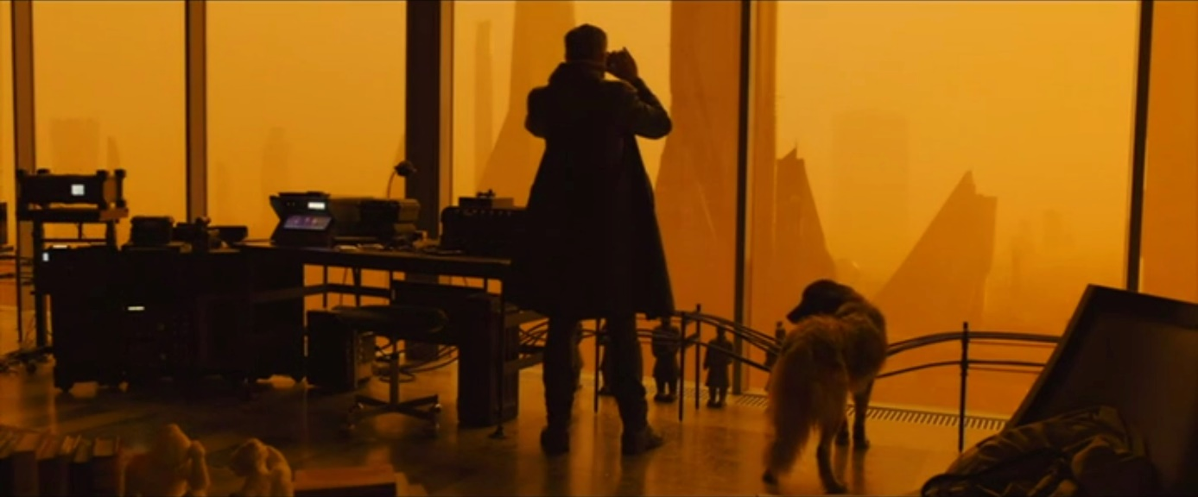

1. The dog not only appears as a living specimen but is also referenced on the sound level. Briefly summarize who calls whom a dog and interpret how this metaphor is used in the context of the social fabric of Blade Runner 2049.
2. Watch the excerpt a second time and pay close attention to the end of the scene. The dog-metaphor can serve as a device that offers a clue about the future of the plot to the audience, before the event takes place. What do you think? Is K completely defeated? Explain and justify your arguments in written form.

**Film genres: Science Fiction & Reality**

1. Examine the following film-stills.

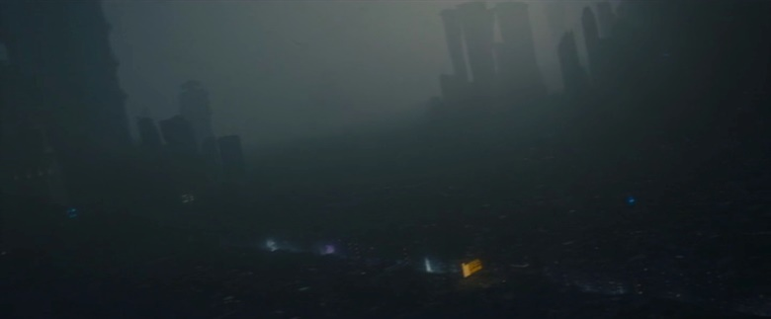

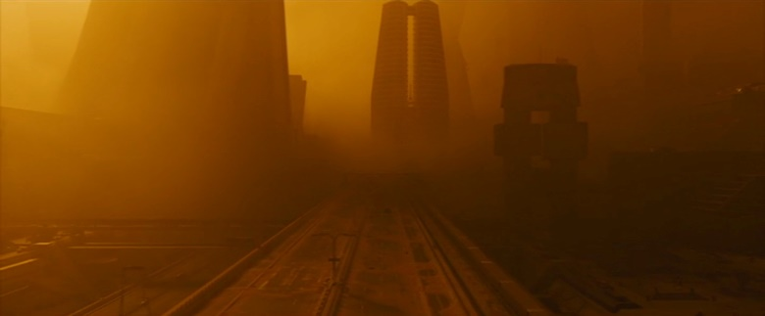

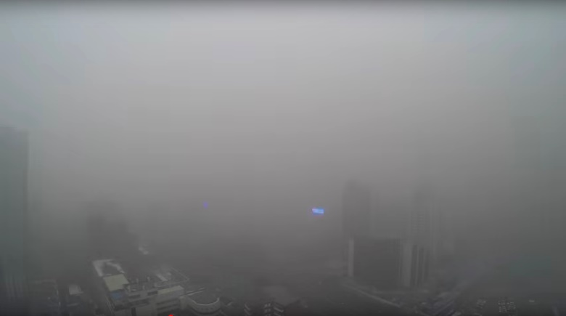

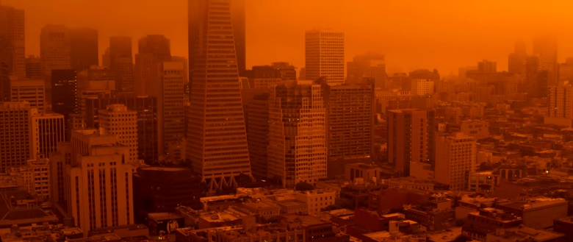

1. Take brief notes of associations that you connect to these images.
2. Describe the images’ effects on you in few sentences and give reasons for the effects.
3. Not all of the images are taken from Blade Runner 2049. Picture 3 and 4 are stills from videos that show real environmental crises.

* <https://www.youtube.com/watch?v=rWOn7op0dew>
* <https://www.youtube.com/watch?v=71C94bXWieI>
  1. Research the background information of the environmental disasters shown in the videos.
  2. The images we are looking at depict a blurring of the lines between fiction and reality. Read the article “#NoFilter” taken from the “Zeit” on September 11th 2020: <https://www.zeit.de/kultur/2020-09/katastrophenbilder-usa-waldbraende-11-september-kalifornien-washington-oregon/komplettansicht>. Take brief notes of the main points and discuss the meaning of the title with your partner.
  3. The cameras were unable to capture accurate pictures of the forest fires in the U.S. because of the white levels. In pairs of two, discuss the question: “What is real?” based on the text. Also, consider to the role of artificial intelligence and holograms in Blade Runner 2049. Try to come up with short definitions.

1. Science fiction paints a picture of the future but always refers to the time in which the work has been created, often including critical commentary. Criticism of the destruction of the environment is a central theme in the universe of Blade Runner 2049. Research the cause for the destruction of the environment in the film’s universe. Include the following excerpt from the Novel “*Do Androids Dream of Electric Sheep?”*by Philip K. Dick, which served as the primary basis for the movie adaptation.

***„The morning air, spilling over with radioactive motes, gray and sun-beclouding, belched about him, haunting his nose; he sniffed involuntarily the taint of death. Well, that was too strong a description for it, he decided as he made his way to the particular plot of sod which he owned along with the unduly large apartment below. The legacy of World War Terminus had diminished in potency; those who could not survive the dust had passed into oblivion years ago, and the dust, weaker now and confronting the strong survivors, only deranged minds and genetic properties.“***

(Source: Philip K. Dick (1996). Do Androids Dream of Electric Sheep? Chapter 1. Excerpt taken from [Penguin Random House Canada](https://www.penguinrandomhouse.ca/books/40617/do-androids-dream-of-electric-sheep-by-philip-k-dick/9780345404473/excerpt))