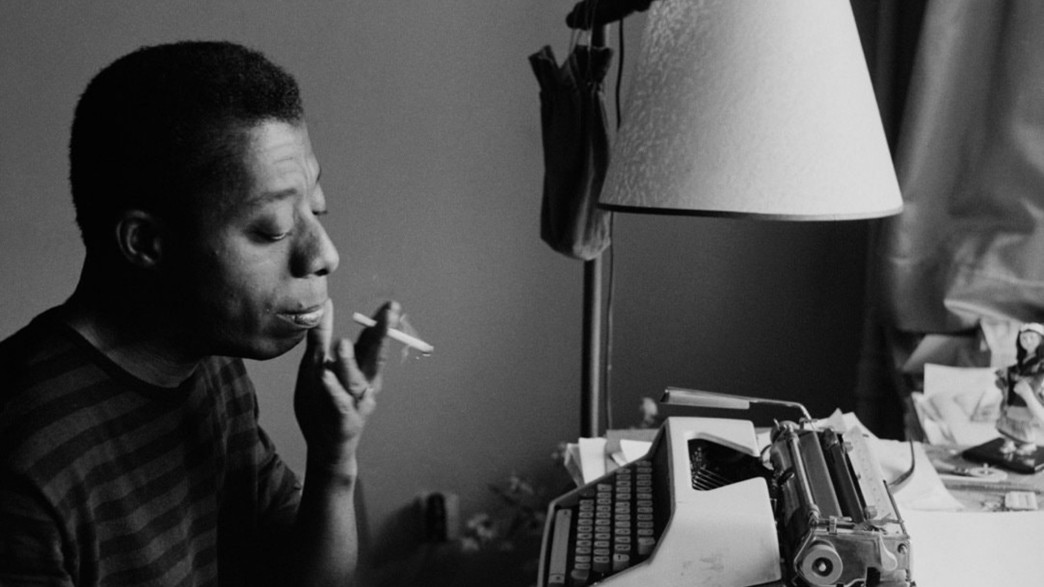

I Am Not Your Negro

Begleitmaterial für den Unterricht
von FILM+SCHULE NRW

Impressum

Herausgeber
FILM+SCHULE NRW
LWL-Medienzentrum für Westfalen
Fürstenbergstraße 13-15
48147 Münster

Autoren
Jelka Luckfiel
Pädagogische Referentin FILM+SCHULE NRW
Jenny Maseray Wagener
Studentische Volontärin SchulKinoWochen NRW
Jannik Arne Beckmann (englische Übersetzung)
Praktikant FILM+SCHULE NRW

Redaktion
Uwe Leonhardt
Geschäftsführer FILM+SCHULE NRW
Ann Kristin vom Ort
Wissenschaftliche Referentin FILM+SCHULE NRW

Gestaltung
Ann Kristin vom Ort
Wissenschaftliche Referentin FILM+SCHULE NRW
Melina Jasmine Kalwey
Studentische Volontärin FILM+SCHULE NRW

Foto Titelseite © lerngut Bildungsmedien
Das gesamte Material unterliegt folgenden Lizenzbedingungen:

FILM+SCHULE NRW ist eine gemeinsame Initiative des Ministeriums für Schule und Bildung des Landes Nordrhein-Westfalen und des LWL-Medienzentrums für Westfalen.

Before the Film
The Exposition – Introduction to the Narrative of the Essay Film

- Carefully watch the opening credits (Timecode 00:00:00-00:02:54). In the opening credits the films themes are introduced and contextualized with video footage and images.

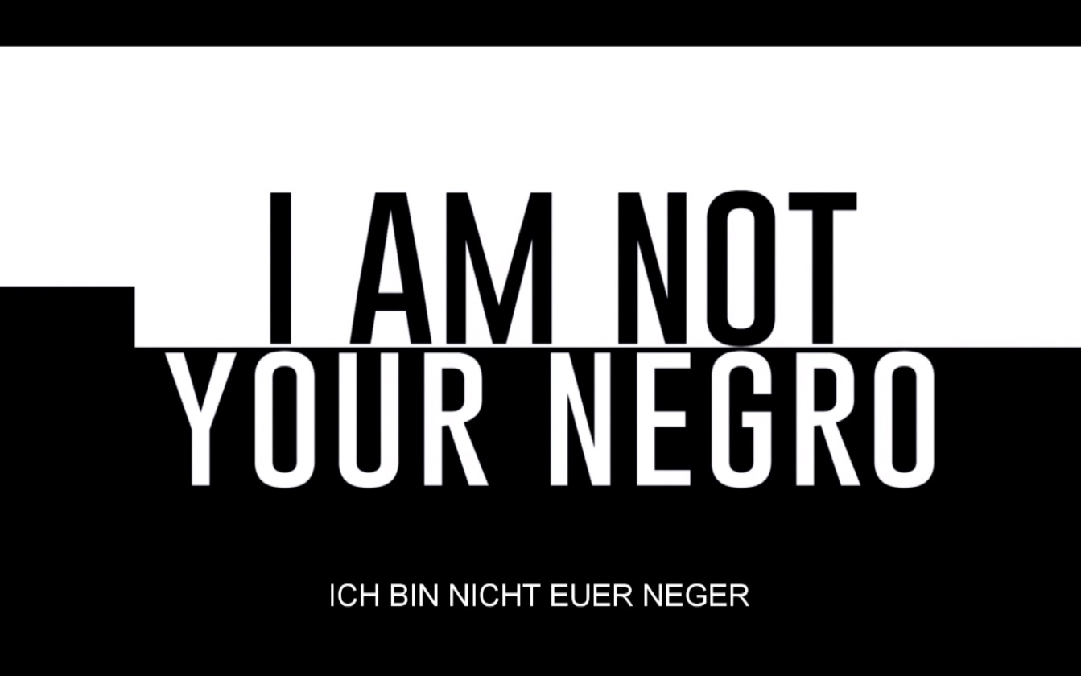

- What expectations do the opening credits evoke for you and why?

- Name the topic – what is the film about?

- What kind of footage is being used and how is it arranged (put together)? What is the created effect?

- Now watch the whole exposition closely (Timecode 00:00:00-00:05:21).

- What effect does the film sequence have on you and why?

- Which different elements are being used on a sound- and visual level? Name them and assign them to the following categories:
  - historical / contemporary,
  - mostly documentary / mostly narrative function

- Whose thoughts are being heard? What is the narrator’s relationship to the sound- and visual level and how is it special? Take the info box below into account.

- a) Read the first four paragraphs of this article to find out what an essay film is:
https://www.dazeddigital.com/artsandculture/article/19816/1/the-secret-history-of-the-essay-film. Familiarize yourself with new vocabulary if necessary.

- In your own words, summarize the distinct characteristics of the essay film.

- In what way can I Am Not Your Negro be categorized as an essay film, based on the exposition? Use your results from the previous tasks.

Info

Voice-Over

A character or a narrator is talking “offscreen”, i.e. the audience can only hear his or her voice. The narrator himself / herself is not visible on screen.

American Heroes and Their Function

- Who is your favorite film hero and why? Interview a partner and take notes of his or her answers.

- Discuss with a partner which characteristics mark a hero and come up with a definition.

- Carefully watch the film excerpts (Timecodes 00:14:40-00:15:56 and 00:59:24 -01:00:38).

  - What do the clips show? Briefly answer the question in full sentences.

  - What is your impression of the different heroes? Describe them with two to three adjectives.

Uncle Tom: _____________________________________________________
Ringo: _________________________________________________________

Ethan: _________________________________________________________

- How does Baldwin judge these characters? Write down your arguments.

- a) Which characteristics mark a hero according to Baldwin and which mechanisms
play a role in that?

- Do these values also play a role in how we judge the behavior of real, e.g. public figures (as heroes) today? Justify your answer by using the documentary´s examples at the end of the second film excerpt. Research its context if necessary.

- What socio-political function does the hero figure have and how would you evaluate it in the context you examined?
Write down your answer in full sentences.

American Heroes – Staging Mechanisms

  - The two film stills are taken from the previous film sequence.

- Which field size and camera angle is being used?

- What is the function of these cinematic devices in relationship to the depiction of each character?

Use the app TopShot for assistance and enter your result into the grid.

Film still 1 | Field Size & Camera Angle
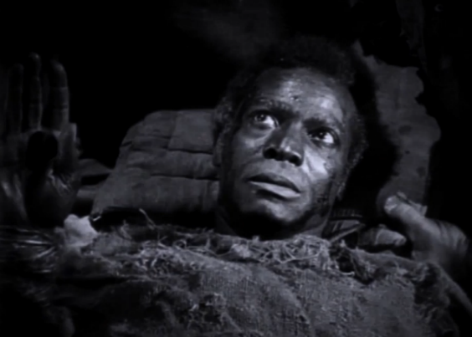
 | Function
Film still 2 | Field Size & Camera Angle
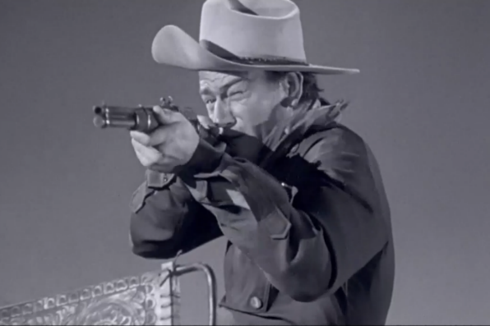
 | Function

  - Put this Baldwin-quote into context.

„Heroes, as far as I could see, were white. And not merely because of the movies but because of the land in which I lived, of which movies were simply a reflection. I despised and feared those heroes because they did take vengeance into their own hands. They thought vengeance was theirs to take and yes, I understood that my countrymen were my enemy.“

Does the depiction of the two characters support or contradict the thesis of the exclusively white hero? Refer to your results from the analysis and write down your findings.

- Carefully watch the sequence (Timecode 00:15:56-00:17:04) and look at these two film stills.
.
- What is your impression of the two children? Take notes of your findings.

James Baldwin: _________________________________________________

Girl: __________________________________________________________

- Analyze the stylistic devices in brief notes.

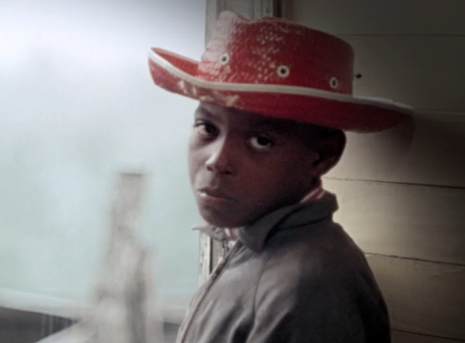
Field size:
Camera Angle:
Color:
Lighting:
Focus:

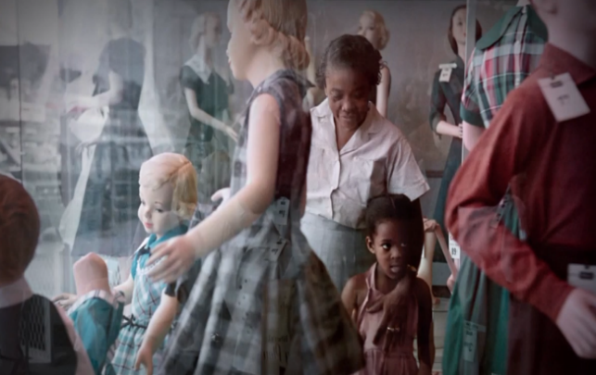
Field size:
Camera Angle:
Color:
Lighting:
Focus:

- There is one object in each film still that has the same color and similar lighting conditions and focus. What does this aesthetic choice express? Which other cinematic device adds to the effect? Interpret the results of your analysis in written form with the help of this question.

- The sequence addresses how James Baldwin, as a little boy, first realized that he belonged to “the others” (i.e. the non-whites). How would that make you feel? Research the narrative mode “Stream of Consciousness“ online. Using this mode, try to loosely recreate the internal monologue the little girl/boy who, for the first time, realizes he/she doesn´t “belong”.

- Revisit the definition of a hero from the opening. Has your perspective on the topic changed through this confrontation? Adjust your definition if necessary and briefly explain in written form if and why it had to be changed or expand upon.

The Immediate Danger

“My frame of reference was George Washington and John Wayne. I was a child with eyes on the world, who uses what he sees. He has nothing else to use. And you are formed by what you see — the choices you have to make, and the way you discover about what it means to be black in New York- […] and then throughout the entire country.“

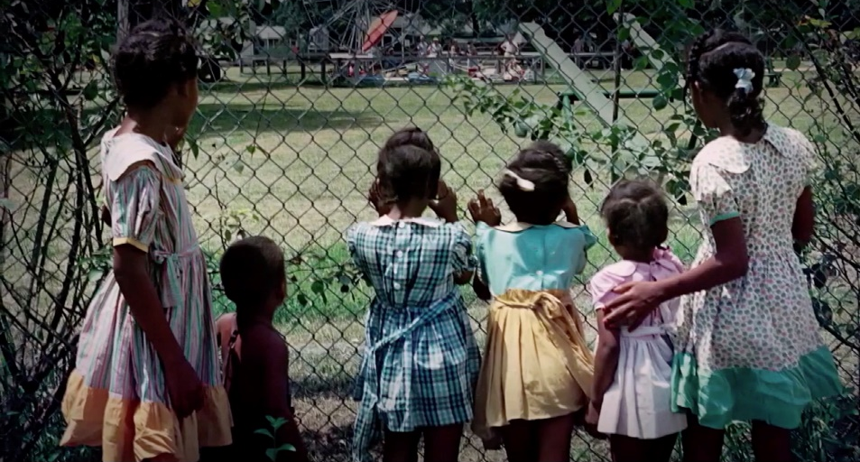

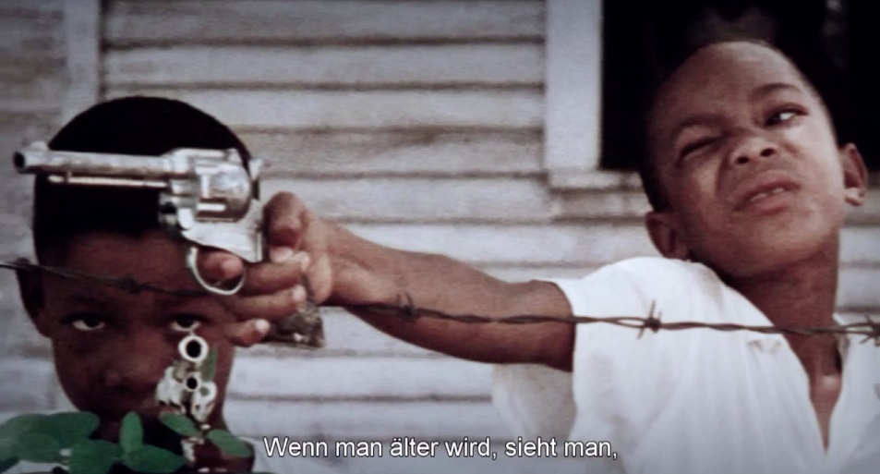

- Take a close look at these film stills.

- What is your impression of these scenes and why?

- Look at the stills in the context of the quote above. How do the depicted children comprehend the world and what does it mean for them to be black? Interpret the pictures in this context.

- Research the significance and historical nature of racial segregation for Afro-Americans even in the 1960´s. What were common forms of everyday-racism? You may find useful information here:

- https://www.geo.de/magazine/geo-epoche/20973-rtkl-usa-den-1960ern-wie-afroamerikaner-unter-der-rassentrennung-litten
- https://www.deutschlandfunkkultur.de/kampf-um-chancengleichheit-in-den-usa-rassistische-gewalt.1024.de.html?dram:article_id=483426
- https://www.history.com/topics/black-history/civil-rights-movement#section_9
- https://www.georgiaencyclopedia.org/articles/history-archaeology/segregation
- https://www.nationalgeographic.com/history/2020/06/2020-not-1968/

- Carefully watch the matching film sequence (Timecode 00:40:31-00:41:34).

  - How does Raoul Peck visually support Baldwin´s speech excerpts? What is the connection between the images shown and the speech and how does it affect you?

  - Research the fate of at least one of these children and teenagers:
Tamir Rice, Darius Simmons, Trayvon Martin, Ayana Stanlay-Jones, Christopher McCray, Cameron Tillman or Amir Brooks.

- How does the following quote by Baldwin relate to the fates of the children or young adults that you have just looked up?

“I know how you watch, as you grow older – and it´s not a figure of speech – the corpses of your brothers and sisters pile up around you. And not for anything they had done. They were too young to have done anything.“

5. a) What does the term: “systemic racism” refer to? Research online.

- Which structure or system does Baldwin explicitly criticize and what conclusion does he draw from it?
Work on the task with the help of the sequence with the timecode 01:07:47-01:11:09. Take notes and write down a summary of your results.

Make-believe Worlds and their Function

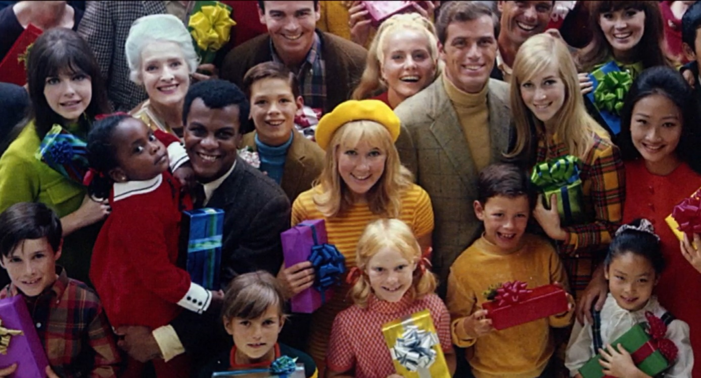

- Examine the film still above closely.

- What effect does the image have on you?

- What period is the still taken from? Which aspect of the image could be an indicator for your observation?

- What is its relation to reality?

- The following film stills are taken from different sequences of the film.

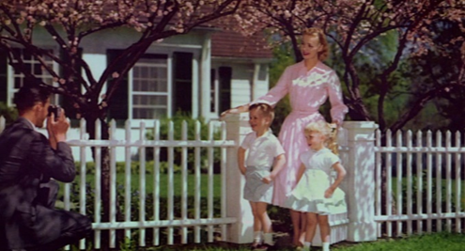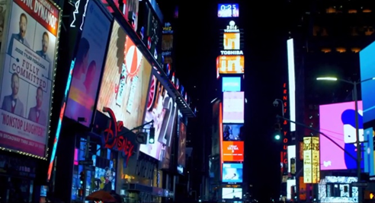

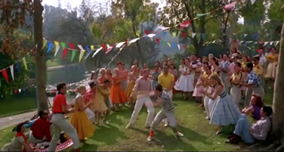

- From which context is this look familiar to you?

- Describe the use of color in more detail. Use the “color” category in the TopShot app to help with your analysis.

- What does the use of color signify and in which content-related context do these stills share? What do they cover up? Write down an explanation.

- Which images are more current and why were they used?

- Carefully watch the film sequences with the timecodes 01:05:31-01:06:19 and 01:11:59-01:12:33. Pay close attention to the quotes of Baldwins text.

- What does Baldwin mean when he says that the industry is compelled to present a self-perpetuating fantasy of the American life to the American people and what is its effect on them? Explain by using examples. You can take the film stills as a starting point or refer to the excerpts.

- How is this industry intertwined with the subjugation and exploitation of minorities? Research these connections if necessary and summarize.

- Why can the white population not “afford to know why their victims are revolting”?

- Do you think Baldwins criticism of the described mechanisms is relevant today? Why/why not? Form an argument based on examples.

The Role of the “Other”

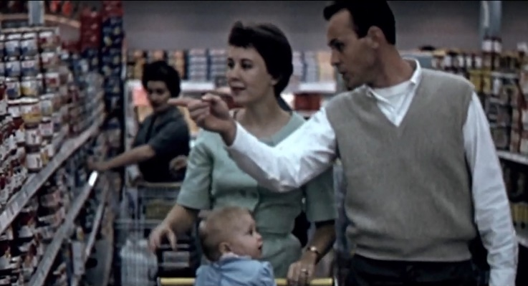
- Carefully watch the film sequence (Timecode: 00:44:27-00:46:06.)

What marks the “failure of public life” and where lies its origin?

Explain by referring to the footage used in the sequence.

- Watch the excerpt taken from the film “No Way Out” (Timecode 00:45:12-00:45:42) a second time.

- What is happening?

- How is the white man’s behavior motivated and how can it be explained?

- In what way does the scene relate to the previous sequence at the shopping mall which it directly follows?

- Examine the following film stills.

- Which adjectives would you use to describe the depicted persons and which role is therefore assigned to them?
For your analysis, consider their presentation (through color, motif, focus, field size, and camera angle).

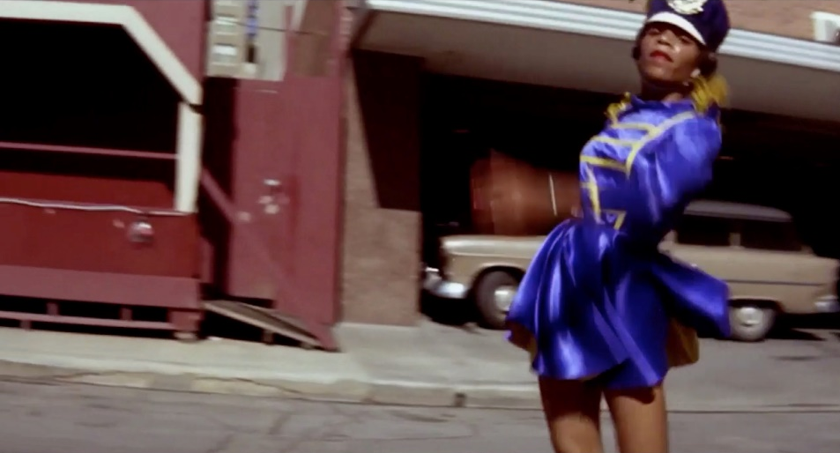
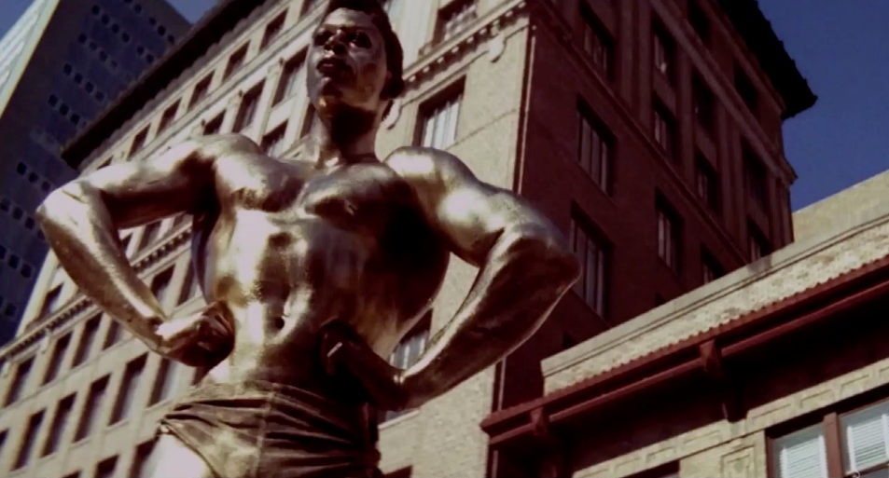

- Write down the antonyms that you have used for task a) and outline (in your head) an alternative draft for the opposite roles for those which you have found in the previous task.

- Research the psychoanalytical technical term projection. In what way is the assigned role (in the picture) the “other” of the society that Baldwin presents. What is the roles function?

- The Austrian ethnologist Andre Gingrich defines “othering” as the “depiction of the powerless “other” according to the interest off the powerful.” How does this definition apply to the representations in the two film stills?
Research the term “othering” on:
https://diversity-arts-culture.berlin/woerterbuch/othering.
Write down an explanation (in English).

- What forms of “othering” are you familiar with in your immediate environment?

- Explain using examples who is portrayed as “other”, what attributes they are given and what function they fulfill in relation to the individuals or society that make these attributions.

- How can we overcome these often racist mechanisms? Which answers does the documentary offer? Which answers sound plausible to you? Discuss.

The Shared Reality

- Carefully watch the film sequence (Timecode 01:04:15-01:05:07).

- What is your impression of the scene and why?

- What does this scene reveal?

- How does it reveal this? Pay special attention to the interplay on the audio- and visual level as well as the use of the voice-over.

- Take a close look at these film stills.

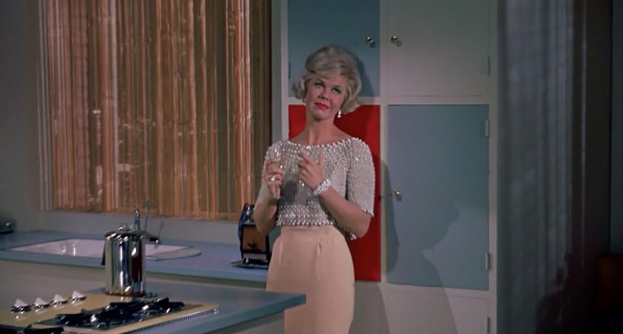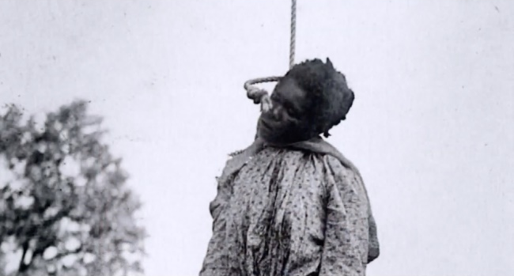

- Describe the first film still. Focus on the motif, field size and camera angle and their effect.

- Which context is the image taken from and what does it represent?

- The second film still is a documented black and white image of Laura Nelson, who was lynched on May 25th, 1922 in Oklahoma. In the film, the second still is shown right after the first one. What effect does this sequencing evoke and why?

- In what way do these images paint over the different realities of the black and white population and what is the narrative purpose of showing the pictures in this order towards the end of the film? Carefully watch the relevant film sequence (Timecode 01:20:26-01:22:10).

- Is the use of the images legitimate? Write a comment.

James Baldwins Self-perception as a Witness

Carefully watch the film sequences with the timecodes 00:28:49-00:29:04 and 00:20:27-00:22:21.

- a) What kind of guilt does James Baldwin feel towards his deceased friends and
their efforts for the civil rights movement? Draw a conclusion from the excerpts and explain your opinion.

- According to Baldwin, what makes up his responsibility as a witness and why? Explain Baldwins statements within the context of the film.

- Baldwin distances himself from four initiatives of the civil rights movement.

- Which are these and what are his reasons for distancing himself? Take notes.

- Which of his friends are part of which movement?
Research additional information about the individual movements online and summarize your results in written form.

- What could Baldwin, in this context, mean by the thin line which separates a witness from an actor?

- Based on your research and personal interest in task 2 b), chose one of the following three civil rights activists:

A Medgar Evers
B Malcolm X
C Martin Luther King

Work on the task sheets on the activist of your choice and find out more about them.

Task Sheet A – Medgar Evers

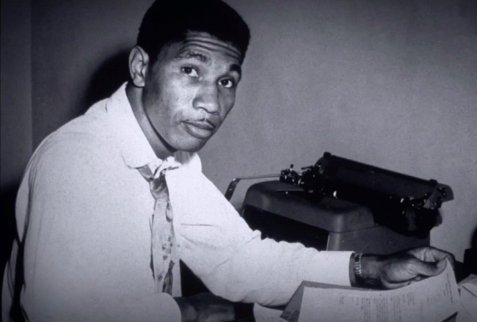
- Carefully watch the film excerpt (Timecode 00:19:57-00:20:25).

- How is this scene constructed on a picture and sound level? What effect does it cause?

- What does the scene tell you about Medgar Evers?

- How does his activism differ from that of Malcolm X and Martin Luther King and what are similarities? Using the excerpt as a starting point, write down the information you can gather from it and research additional information.

- Carefully watch the film excerpt (Timecode 00:36:07-00:39:04).

- How do you feel after viewing it and why?

- How and with which cinematic devices is Medgar Evers fate portrayed? Argue by referring to aspects of the excerpt.

- Which other narrative models could have been used? Why do you think this mode was ultimately chosen?

- What could have led to the decision not to address the identity of the perpetrator and his motives in the film’s narrative?

- Towards its end the sequence shows Bob Dylan and his song “Only a pawn in their game” which is dedicated to Medgar Evers. It became a famous protest-song of the civil rights movement.

- Look up the lyrics to the song.

- In which context does Dylan frame the murder and what does he implicitly criticize?

Task Sheet B – Malcolm X

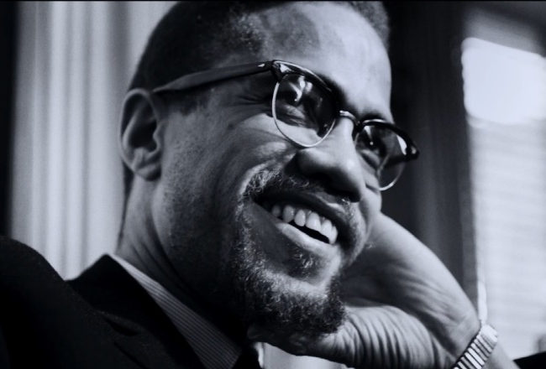
1. Carefully watch the film excerpts (Timecodes 00:18:26-00:19:30 and 00:25:31-00:28:47).

- How are those scenes constructed on a picture and sound level? What is the caused effect?

- What do the scenes tell you about Malcolm X and his reception within the white society?

- What is Malcom X´s position in contrast to that of Martin Luther King Jr. and what are the similarities? Take the excerpts as a starting point and gather additional information online.

- Carefully watch the film sequence (Timecode 01:00:40-01:02:05).

- How do you feel after the viewing and why?

- How and with which cinematic devices is Malcom X´s fate portrayed? Argue by referring to aspects of the excerpt.

- Which other narrative models could have been used? Why do you think this mode was ultimately chosen?

- What could have led to the decision not to address the identity of the perpetrator and his motives in the film’s narrative?

- Watch the film sequence (Timecode 01:02:06-01:04:16).

- In what way can Baldwins speech be understood as a defense of Malcom X? Do his arguments convince you? Write down your reasoning.

- How does the documentary footage relate to the content of the speech and Malcom X?
Task Sheet C – Martin Luther King

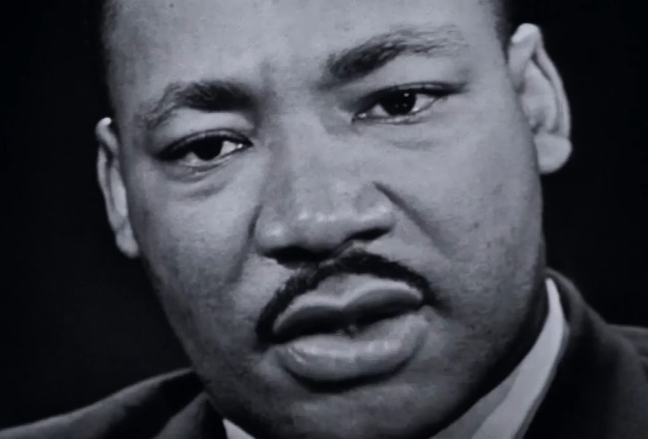
- Watch this sequence taken from a talk show (Timecode 00:25:31-00:28:47).

- How is this scene constructed on a picture and sound level? What is the caused effect?

- What do you learn about Martin Luther King Jr.?

- What is Martin Luther King’s position in contrast to that of Malcom X and what are similarities? Take the excerpt as a starting point and gather additional information online.

- Carefully watch the film sequence (Timecode 01:13:35-01:17:05).

- How do you feel after the viewing and why?

- How and with which cinematic devices is Martin Luther King Jr.´s fate portrayed? Argue by referring to aspects of the excerpt.

- Which other narrative models could have been used? Why do you think this mode was ultimately chosen?

- What could have led to the decision not to address the identity of the suspected perpetrator and his motives in the film’s narrative?

- The death of Martin Luther King Jr. became a matter of great public interest. Many protest rallies and speeches were held afterwards. The song “The Ballade of Birmingham” is used to accompany the footage from the funeral and peaceful protests.

- Look up the lyrics and background information on the song.

- How does it mirror the context in which Martin Luther King Jr. was assassinated?
Which symbolic significance does the assassination contain beyond the personal tragedy?

Testimony

1. Carefully read through this quote and re-watch the sequence it was taken from: (Timecode 01:22:16-01:23:34).

“You cannot lynch me and keep me in ghettos without becoming something monstrous yourselves. And furthermore, you give me a terrifying advantage. You never had to look at me. I had to look at you. I know more about you than you know about me. Not everything that is faced can be changed. But nothing can be changed until it has been faced. History is not the past. It is the present. We carry our history with us. We are our history. If we pretend otherwise, we literally are criminals. I attest to this: The world is not white. It never was white, cannot be white. White is a metaphor for power, and that is simply a way of describing Chase Manhattan Bank.”

- What comes to your mind after watching this scene?

- What kind of pictures accompany Baldwin´s words and what is their function regarding the original context of this speech?

- According to Baldwin, what makes you a criminal and how can this presumed connection be understood? Explain on the basis of examples from the film.

- In what way does the sentence: “I attest to this: The world is not white” summarize Baldwins entire critique of society? Discuss.

2. How can Raoul Pecks Job as the director of I Am Not Your Negro be understood as the task of a witness and which different cinematic techniques does he include? Write down an explanation based on a scene of your choice.

3. I Am Not Your Negro was shown at the Berlinale in 2017. The director Raoul Peck addressed the European audience. Carefully watch this clip on YouTube:
https://www.youtube.com/watch?v=ILSoJBApqwY

- Would you have expected Peck to relate the films message directly to Europe? Why or why not?

- In what regard can Baldwins statements be understood in relation to Germany and Europe? Use this collection of headlines as inspiration to research the connections (e.g. on the internet) and write down your findings and thoughts afterwards.

- Why is the sentence “White is a metaphor for power” the most important phrase of the whole movie for Peck? Write down possible explanations and give reasons for them.

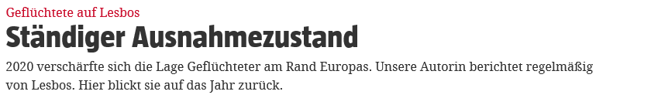

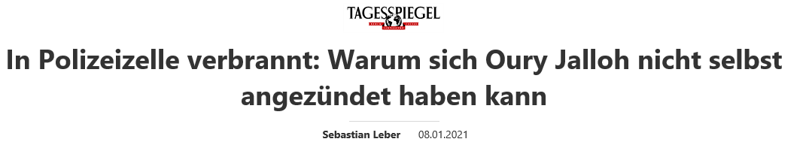

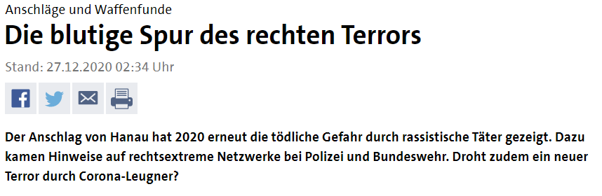

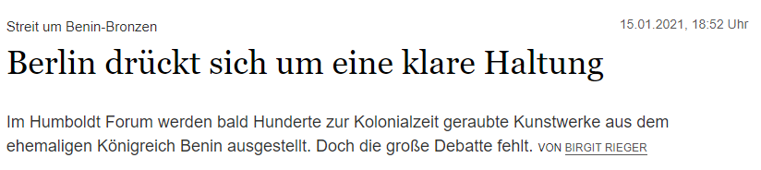

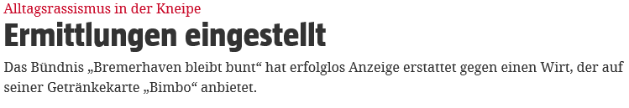

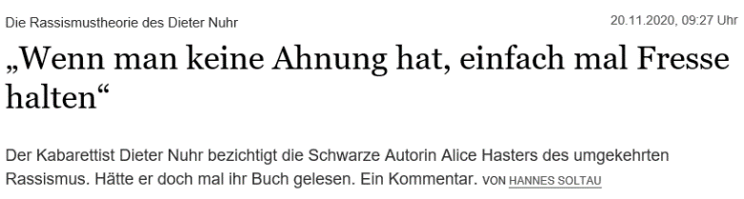

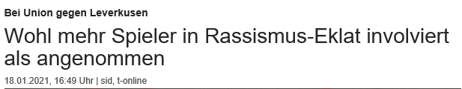

Closing Thoughts

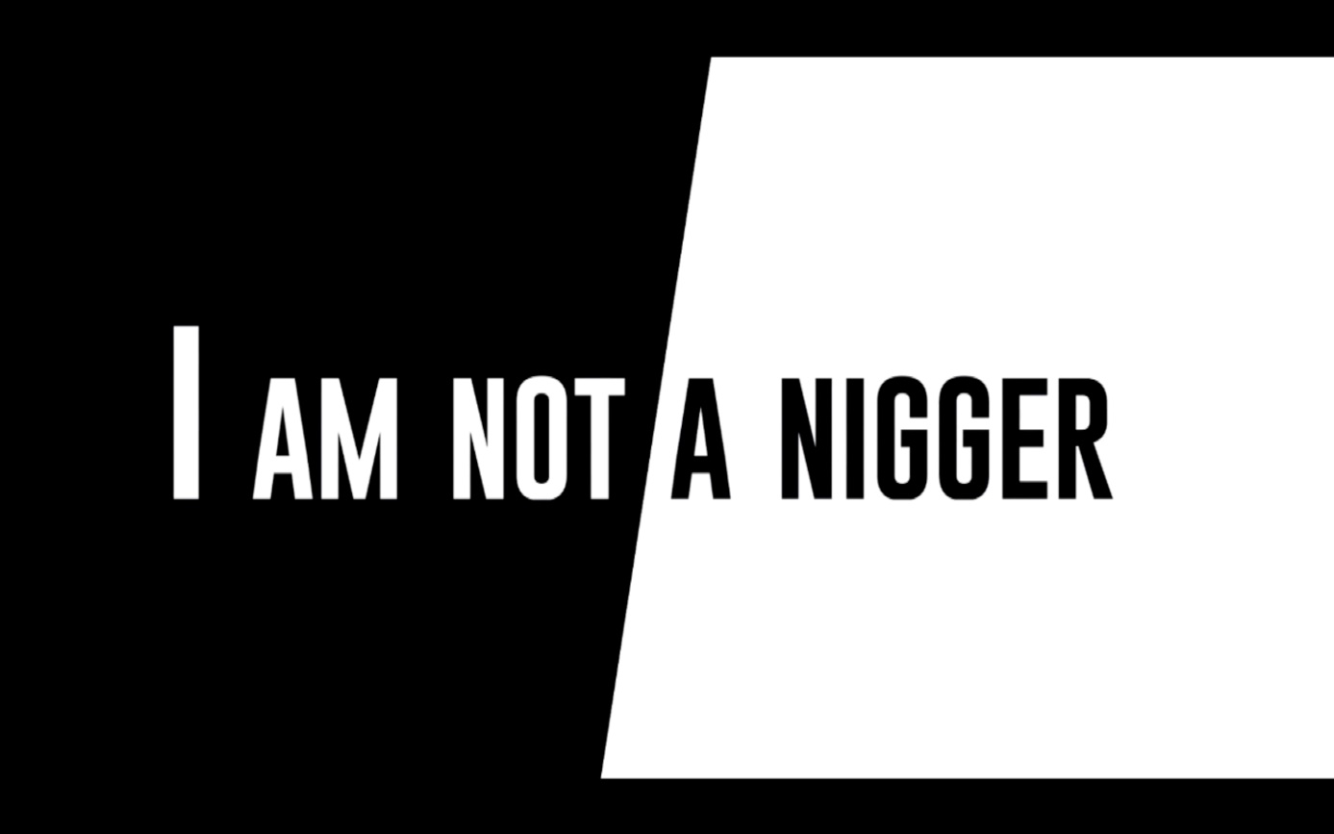

- The film’s final chapter is called “I am not a nigger”.

- Where does the term “Nigger” originate? What is its connotation and how is it still used in parts of certain subcultures? What do you think about that?
Research additional information online and summarize your findings.

- What does Baldwin express with this wording?

- What is the function of this verbal exaggeration towards the end of the film in relation to the title I Am Not Your Negro?

- Watch the final scene of the film (Timecode 01:24:21-01:26:01).

- What does Baldwin mean by the metaphor that the castration of black people is the American fact? Write down your thoughts based on your impressions of the film and the presented circumstances.

- What are some possible answers the film may suggest to the question: why the white man needed a “nigger” in the first place?

- Does this statement from 1963 feel relevant today? Relate it to the current situation in the U.S. and conclude what has changed since then. Has the question been addressed by society?

- The song that is played during the final credits of the film is called “The blacker the berry” by Kendrick Lamar and immediately follows Baldwins closing statement in the film.

- Look up Kendrick Lamar, the song and lyrics on the internet and relate them to the topic of the film. Take Notes of your findings.

- What is the songs connection to Baldwins quote, which it follows in the film?

- Which significance unfolds through the use of this contemporary hip-hop song in the final credits?

External Sources

AB The Role of the “Other”

Andre Gingrich: Othering. In: derselbe, Fernand Kreff, Eva-Maria Knoll (Hrsg.): Lexikon der Globalisierung. Bielefeld 2011. S. 323.

AB Testimony

https://taz.de/Gefluechtete-auf-Lesbos/!5735944/ 26.01.21, 10:42 Uhr.
https://www.sueddeutsche.de/politik/rechtsextremismus-polizei-nrw-1.5126248 26.01.21., 10:43 Uhr.
https://m.tagesspiegel.de/in-polizeizelle-verbrannt-warum-sich-oury-jalloh-nicht-selbst-angezuendet-haben-kann/26774236.html 26.02.21, 10:44 Uhr.
https://www.zeit.de/gesellschaft/zeitgeschehen/2020-03/flucht-mittelmeer-fluechtlinge-migration-vereinte-nationen26.01. 21 10:49 Uhr.
https://www.tagesschau.de/inland/rechtsextremismus/terrorismus-121.html 26.01.21, 10:51 Uhr.
https://www.sueddeutsche.de/panorama/sinti-und-roma-polizei-racial-profiling-berlin-1.5176954 26.01.21, 10:55 Uhr.
https://www.sonntagsblatt.de/artikel/studie-viele-migranten-koennen-sich-ihren-jobs-kaum-entwickeln 26.01.21, 10:58 Uhr.
https://www.zeit.de/politik/deutschland/2021-01/asyl-erstantrag-rueckgang-fluechtlinge-deutschland 26.01.21, 10:59 Uhr.
https://www.tagesspiegel.de/kultur/streit-um-benin-bronzen-berlin-drueckt-sich-um-eine-klare-haltung/26821970.html 26.01.21, 11:01 Uhr.
https://taz.de/Alltagsrassismus-in-der-Kneipe/!5738223/ 26.01.21, 11:02 Uhr.
https://www.tagesspiegel.de/kultur/die-rassismustheorie-des-dieter-nuhr-wenn-man-keine-ahnung-hat-einfach-mal-fresse-halten/26632806.html 26.01.21, 11:04 Uhr.
https://www.t-online.de/sport/fussball/bundesliga/id_89304382/rassismus-eklat-bei-union-berlin-mehr-spieler-als-angenommen-involviert.html 26.01.21, 11:06 Uhr.

