

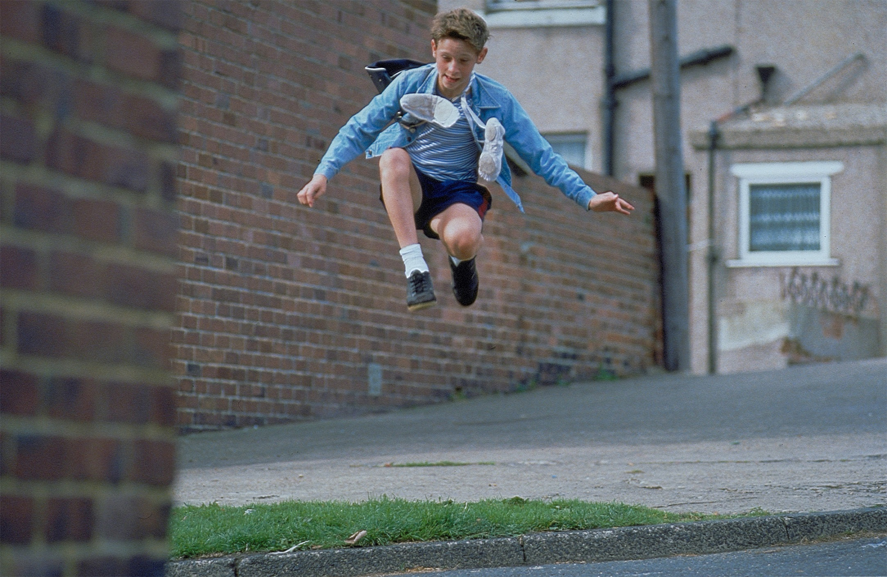



**Billy Elliot**

Begleitmaterial für den Unterricht   
von FILM+SCHULE NRW



**Impressum**

**Herausgeber**

FILM+SCHULE NRW

LWL-Medienzentrum für Westfalen

Fürstenbergstraße 13-15

48147 Münster

**Autoren**

Manfred Rüsel   
Filmpädagoge, Autor, Lehrer an der Europaschule Langerwehe

Ann Kristin vom Ort

Wissenschaftliche Referentin FILM+SCHULE NRW

Jannik Arne Beckmann (englische Übersetzung)

Praktikant FILM+SCHULE NRW

**Redaktion**

Uwe LeonhardtGeschäftsführer FILM+SCHULE NRW

Jelka Luckfiel

Pädagogische Referentin FILM+SCHULE NRW

**Gestaltung**

Ann Kristin vom Ort

Wissenschaftliche Referentin FILM+SCHULE NRW

Melina Jasmine Kalwey  
Studentische Volontärin FILM+SCHULE NRW

**Foto Titelseite** © Universal Pictures

Das gesamte Material unterliegt folgenden Lizenzbedingungen:

FILM+SCHULE NRW ist eine gemeinsame Initiative des Ministeriums für Schule und Bildung des Landes Nordrhein-Westfalen und des LWL-Medienzentrums für Westfalen.





**Analysis of the Exposition**

1. Carefully watch the first eight minutes of Billy Elliot – I Will Dance.

a) Answer the following questions:

* Where does the movie take place?
* At what time is the film set?
* Describe Billy Elliot. What does he enjoy doing, what does he dislike? What issues is he dealing with?
* What information is given to us about his father, his grandmother and possible other characters?
* What kind of tone is established in the first 8 minutes?
* What could be the themes the movie deals with?

Enter your responses into the column titled “Description“ in the table below.

|  |  |  |
| --- | --- | --- |
|  | **Description** | **Explanation** |
| **Setting** |  |  |
| **Time** |  |  |
| **Billy Elliot** |  |  |
| **Father** |  |  |
| **Grandmother** |  |  |
| **Tony** |  |  |
| **Other  Charachters** |  |  |
| **Tone** |  |  |
| **Possible  themes** |  |  |

1. Now write into the „Explanation“ column how you learned that information or what aspect of the movie you gathered it from.
2. Compare your results with the other students and complete your table.
3. Now watch the opening of the movie a second time and answer these questions:
4. How can you tell that Billy´s family doesn´t have a lot of money?
5. What could have happened to Billy´s mother?
6. What could be the cause of the conflict between the people who are striking and the police?
7. Gather information about the miners’ strike of 1984-1985 with the help of the material from the “Big Pit: National Coal Museum“ (<https://museum.wales/media/9753/strike-en.pdf>).
8. Read pages 3 to 8 of the short presentations.
9. Create a mind map in which you outline the central information about the miners´ strike and those who played an important role in it.
10. Who was Margaret Thatcher? Do a quick online research of her and fill in her short profile.

**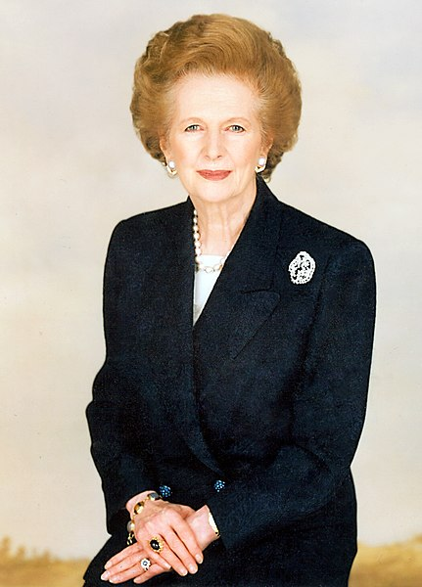Name:**

**\* on: † on:**

**Political office from 1979 until 1990:**

**Role in the miners´ strikes:**

**Billy as a Boxer**

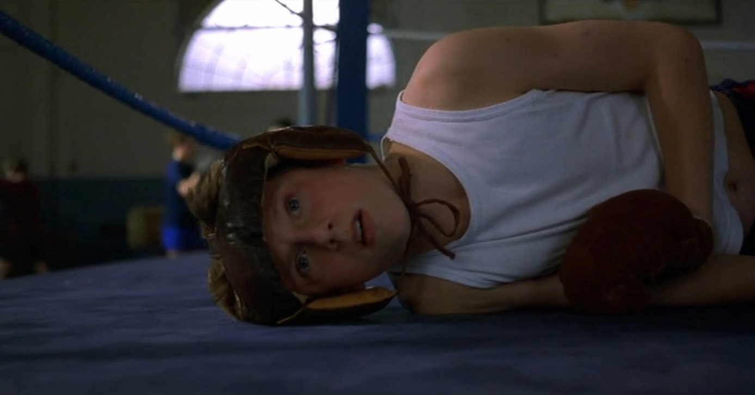

1. Billy´s father sends him to boxing practice. The film still above shows Billy in a sparring fight.
2. Indicate with a mark on the scale below how Billy must be feeling in this moment.

unhappy happy

1. Use the App TopShot to familiarize yourself with different camera angles and field sizes.

Which field size and camera angle is used to portray Billy and what is the resulting effect? Take brief notes of your answers.

Field size: \_\_\_\_\_\_\_\_\_\_\_\_\_\_\_\_\_\_\_\_\_\_\_\_\_\_\_\_\_\_\_\_\_\_\_\_\_\_\_\_\_

Effect: \_\_\_\_\_\_\_\_\_\_\_\_\_\_\_\_\_\_\_\_\_\_\_\_\_\_\_\_\_\_\_\_\_\_\_\_\_\_\_\_\_

Camera angle: \_\_\_\_\_\_\_\_\_\_\_\_\_\_\_\_\_\_\_\_\_\_\_\_\_\_\_\_\_\_\_\_\_\_\_\_\_\_\_\_\_

Effect: \_\_\_\_\_\_\_\_\_\_\_\_\_\_\_\_\_\_\_\_\_\_\_\_\_\_\_\_\_\_\_\_\_\_\_\_\_\_\_\_\_

1. The film still below shows the fathers reaction to the outcome of Billy´s fight. What could be going through Billy´s head after seeing this reaction?

Write a short monologue (5-6 sentences).

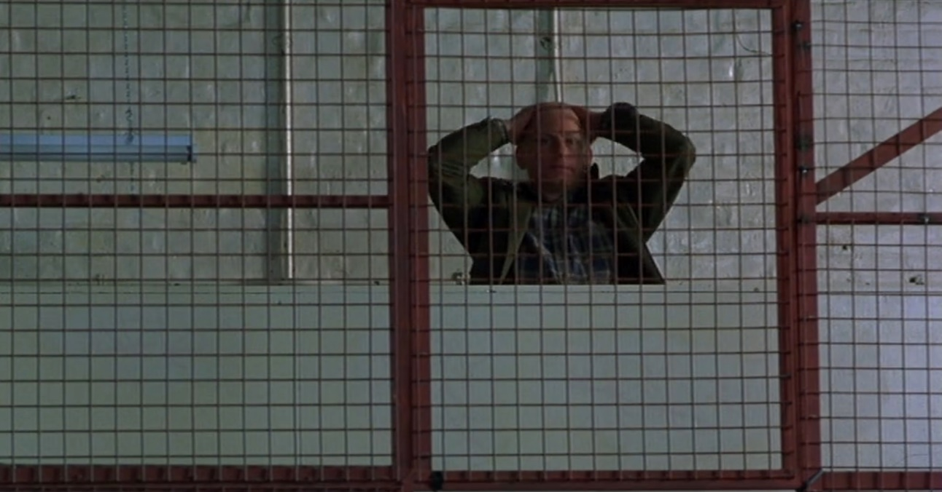

1. How can the relationship between Billy and his father be described? What is expected of Billy? Take the film still from Task 2 and the quote from Billy´s boxing coach as a starting point to briefly describe the relationship between Billy and his father.

“Jesus Christ, Billy Elliot! You´re a disgrace to them gloves, your father and the traditions of this boxin´ hall! You owe us 50 pence**.**“

1. After boxing practice, Billy must stay at the gym and continue practicing. He begins watching Mrs. Wilkinson’s ballet lessons and eventually starts joining them.
2. Carefully watch the film excerpt (00:09:00-00:11:30).
3. Write a diary entry from the perspective of Billy, in which you describe the day’s events and reveal your thoughts, feelings and hopes.

**The Ship**

1. A sailing ship can be found in two scenes in Billy Elliot – I Will Dance. The film stills in the table below are taken from those scenes.
2. Describe who and what can be seen in the picture and which version of a sailing ship is being shown. Also note what impression of Billy you get in this picture.

|  |
| --- |
| **Film still 1** |
| **V:\Film_und_Schule\Unterrichtsmaterial+Tools\Ausgezeichnet!\Unterrichtsmaterial\Ausgezeichnet!_Arbeitsblattsets\Billy_Elliot\Set SKW 2021\Segelschiff1.jpg** |
| **Description:** |

|  |
| --- |
| **Film still 2** |
| **V:\Film_und_Schule\Unterrichtsmaterial+Tools\Ausgezeichnet!\Unterrichtsmaterial\Ausgezeichnet!_Arbeitsblattsets\Billy_Elliot\Set SKW 2021\Segelschiff2.jpg** |
| **Description:** |

1. The ship symbolizes a journey. Taken as a metaphor, crossing the ocean with a ship can symbolize the journey of a human’s lifetime, with all its possibilities and dangers.

Think about how the ship could function as a symbol for Billy´s story. Also, consider the context of the scenes in which the ship is shown: The first still shows Billy on the evening before he met the ballet teacher Mrs. Wilkinson after boxing practice. A ship appears a second time after an argument about Billy´s future as a dancer breaks out between Mrs. Wilkinson, Tony and Billy’s father. Billy cannot bear the fighting any longer and angrily dances across the street.

**Billy as a Dancer**

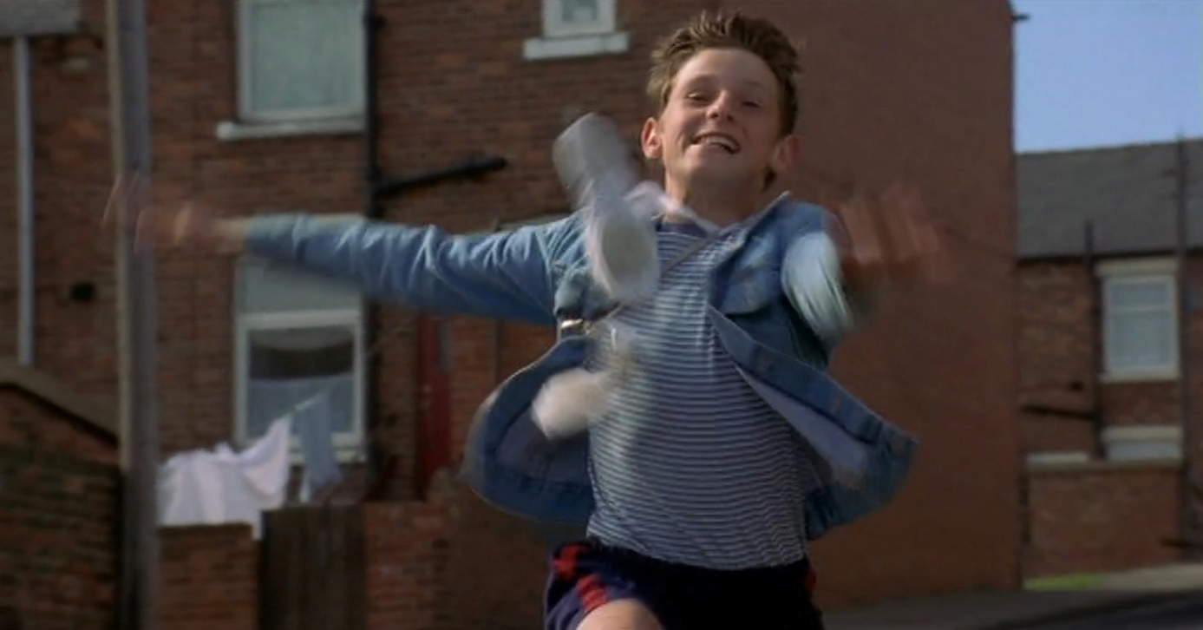

1. Billy starts joining Mrs. Wilkinson’s ballet lessons. The film still above shows Billy after a lesson in which he mastered a difficult ballet technique.
2. Indicate with a mark on the scale below how Billy must be feeling in this moment.

unhappy happy

1. Use the App TopShot again to familiarize yourself with different camera angles and field sizes.

Which field size and camera angle is used to portray Billy and what is the resulting effect? Take brief notes of your answers.

Field size: \_\_\_\_\_\_\_\_\_\_\_\_\_\_\_\_\_\_\_\_\_\_\_\_\_\_\_\_\_\_\_\_\_\_\_\_\_\_\_\_\_

Effect: \_\_\_\_\_\_\_\_\_\_\_\_\_\_\_\_\_\_\_\_\_\_\_\_\_\_\_\_\_\_\_\_\_\_\_\_\_\_\_\_\_

Camera angle: \_\_\_\_\_\_\_\_\_\_\_\_\_\_\_\_\_\_\_\_\_\_\_\_\_\_\_\_\_\_\_\_\_\_\_\_\_\_\_\_\_

Effect: \_\_\_\_\_\_\_\_\_\_\_\_\_\_\_\_\_\_\_\_\_\_\_\_\_\_\_\_\_\_\_\_\_\_\_\_\_\_\_\_\_

1. Once his father realizes that Billy has found happiness in dancing and that he will not let anything stop him from pursuing that dream, he begins to support him on his way to becoming a professional dancer.
2. What does Billy´s father do to give his son a chance to learn ballet at the Royal Ballet School? Which personal sacrifices and efforts does it take? Take notes.
3. The still below shows Billy´s father, years later at the grown-up Billy´s first big show as a professional ballet dancer. Why does Jackie cry? How do field size and camera angle affect your view? Give a written explanation.

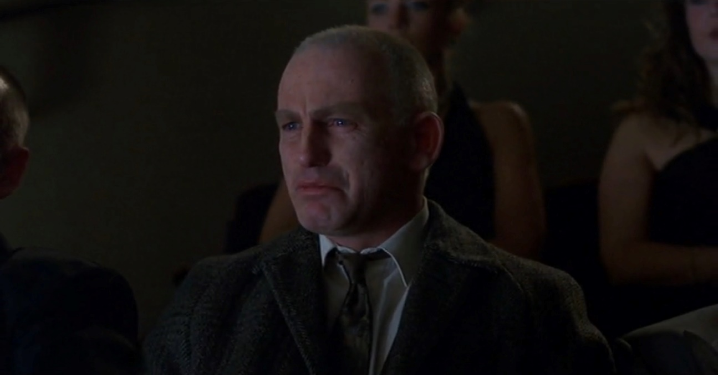

1. Has Jackie been (or become) a good father to Billy? Give reasons as to what qualities he has shown over the course of the film.