The Hate U Give

Begleitmaterial für den Unterricht
von FILM+SCHULE NRW

Impressum

Herausgeber
FILM+SCHULE NRW
LWL-Medienzentrum für Westfalen
Fürstenbergstraße 13-15
48147 Münster

Autoren
Ann Kristin vom Ort
Wissenschaftliche Referentin FILM+SCHULE NRW
Jannik Arne Beckmann (englische Übersetzung)
Praktikant FILM+SCHULE NRW

Redaktion
Uwe Leonhardt
Geschäftsführer FILM+SCHULE NRW
Jelka Luckfiel
Pädagogische Referentin FILM+SCHULE NRW

Gestaltung
Ann Kristin vom Ort
Wissenschaftliche Referentin FILM+SCHULE NRW
Melina Jasmine Kalwey
Studentische Volontärin FILM+SCHULE NRW

Foto Titelseite © Katholisches Filmwerk GmbH (kfw)
Das gesamte Material unterliegt folgenden Lizenzbedingungen:

FILM+SCHULE NRW ist eine gemeinsame Initiative des Ministeriums für Schule und Bildung des Landes Nordrhein-Westfalen und des LWL-Medienzentrums für Westfalen.

Starr

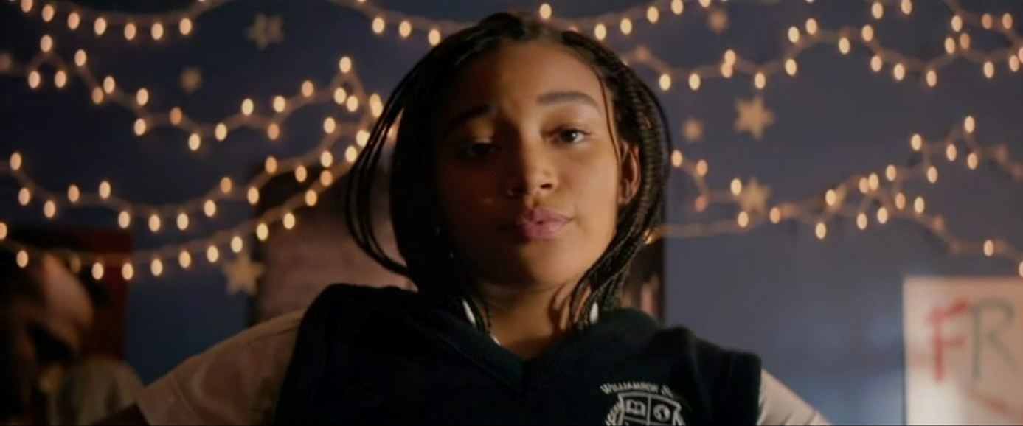

- At the beginning of the film, you are introduced to high school-student Starr Carter and get to know her family. (Timecode: 00:03:10-00:06:24).

- Watch the film excerpt carefully. What kind of impression does Starr make on you and why? Choose three adjectives, which accurately describe Starr from your perspective and briefly explain your choice.

- _____________________, because _______________________________
- _____________________, because _______________________________
- _____________________, because _______________________________

- Take a look at the film still at the top of the page. Use the App TopShot to familiarize yourself with different camera angles and field sizes. In which field size and camera angle is Starr being portrayed and what is the resulting effect? Take brief notes of your answers.

Field size: _________________________________________
Effect: _________________________________________
Camera angle: _________________________________________
Effect: _________________________________________
- Watch the film excerpt with the timecode 00:06:24-00:12:40. Starr explains how, at her high school, she becomes „Starr version 2“.

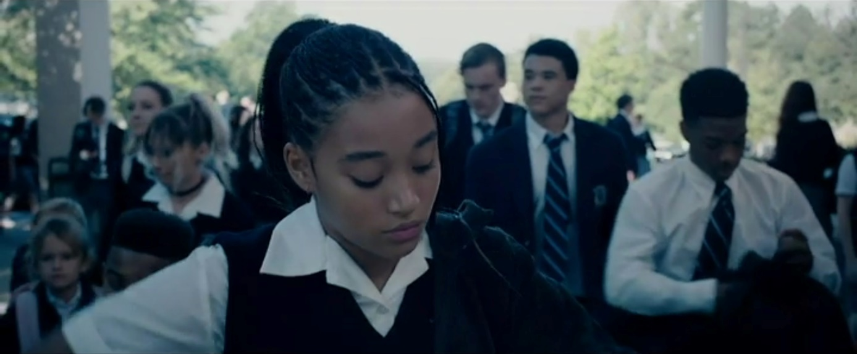

- Watch the film excerpt carefully. What kind of impression does Starr make on you and why? Choose three adjectives, which accurately describe Starr from your perspective and briefly explain your choice

- _____________________, because _______________________________
- _____________________, because _______________________________
- _____________________, because _______________________________

- Take a look at the film still at the top of the page. Use the App TopShot to familiarize yourself with different camera angles and field sizes. In which field size and camera angle is Starr being portrayed and what is the resulting effect? Take brief notes of your answers.

Field size: _________________________________________
Effect: _________________________________________
Camera angle: _________________________________________
Effect: _________________________________________

- Compare the effect of the film still that shows Starr at home (Task 1) with the effect of the still that shows her at school (Task 2) and explain how the different field sizes and camera angles visually express Starr’s two different versions.

- Starr lives in two worlds. Right at the beginning of the film you get to know both her neighborhood Garden Heights and her high school – Williamson Prep. How do these two worlds differ? Analyze the film stills with regard to the cinematic devices by taking brief notes in the table on the next page and compare them afterwards.

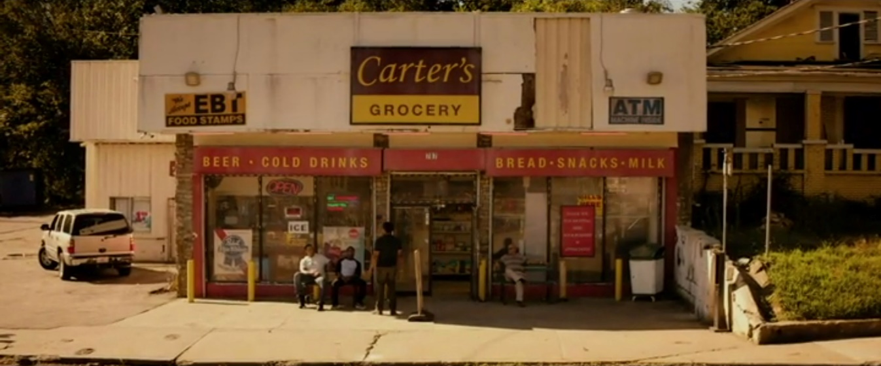

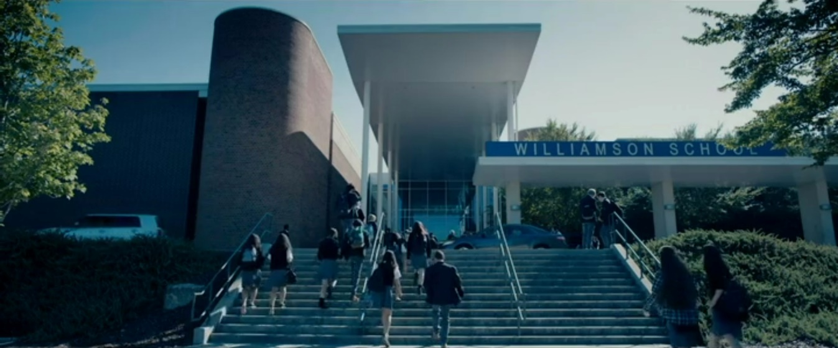

Garden Heights | Williamson Prep
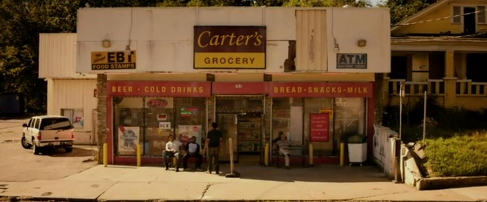 | 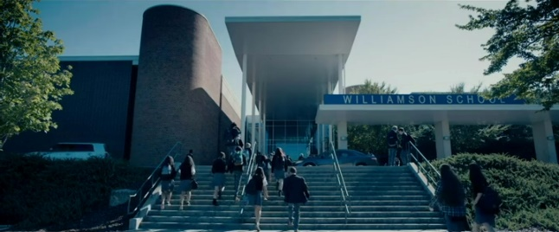
People: | People:
Architecture: | Architecture:
Color/Light: | Color/Light:
Field size: | Field size:
Camera angle: | Camera angle:
Effect: | Effect:

- Starr says that she hates herself for behaving differently in school than she does at home.

- What are her reasons for changing herself even though she hates it?

- Can you understand why she would behave like that? Would you act the same way or handle the situation differently? Give a written response.

Khalil

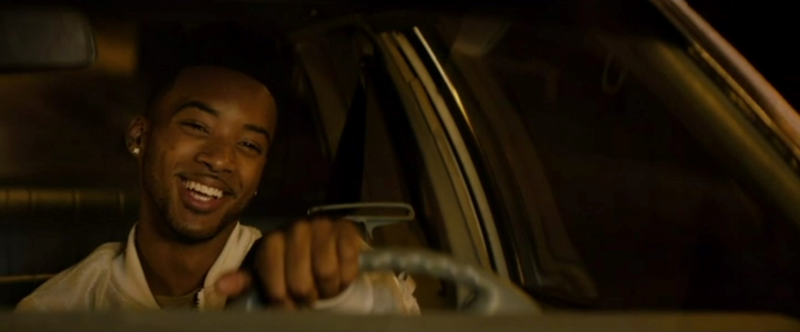

- This film still is taken from the scene in which Khalil is giving Starr a ride home.

- What impression does Khalil make on you and why?

- Khalil is wearing a white jacket. What could be the its significance, given the context of the scene?

Write down your responses in whole sentences.

- Khalil is a fan of the rapper 2Pac. In the car, he explains the Acronym THUG LIFE to Starr, which summarizes 2Pac’s general philosophy. Watch the excerpt (Timecode: 00:18:40-00:19:52) and work on the following tasks.

- What do the individual letters in THUG LIFE stand for?

- Find connections between the motto THUG LIFE and the events of Starr’s and Khalil’s childhood. Write down your ideas.

- Research Tupac Shakur online and put the relevant information in relation to the film’s themes.

Racism and Police Brutality

The Talk

The prologue of the film The Hate U Give shows a very serious conversation within a family. (Timecode: 00:00:40-00:02:40).

- What is the topic of that conversation? Summarize briefly.

- Imagine your parents having such a conversation with you. What kind of thoughts would be going through your head, how would it make you feel? Write down your thoughts in the form of a diary entry.

- Afterwards, read through the article: „Black Parents describe “The Talk” they give to their children about the police” by German Lopez on Vox.com (https://www.vox.com/2016/8/8/12401792/police-black-parents-the-talk) OR watch the bonus video “The Talk” via your Edmond NRW link. You can find it in the main menu by selecting “Extras”. Take notes on the essential pieces of information about the topic.

- Using your own words, summarize the situation of African Americans living in the U.S..

The Traffic Stop

After a party, Starr and her friend Khalil are being pulled over by a policeman on their way home. The routine traffic stop takes a tragic turn when the policeman shoots Khalil. (Timecode: 00:23:45-00:27:55).

- How did this situation come to be? Briefly describe the procedure of the traffic stop.

- How did Khalil behave differently from Starr, who strictly stuck to her father’s instructions?

- From your point of view, were the policeman’s actions justified? Could he have acted differently and therefore changed the outcome of the situation?

Police Brutality in the USA & Black Lives Matter

The film The Hate U Give is based on a novel by the African American writer Angie Thomas. The author herself cites recent cases of police brutality against Afro-Americans as well as the Black Lives Matter movement, which was founded in 2013, as inspirations for her novel.
Khalils story is fictional. But the story of George Floyd, Philando Castile, Oscar Grant, Tamir Rice and many more US-American citizens is not. They are a sad reality. All of these people have fallen victim to those who have sworn an oath to protect all American citizens.

- Read through the text „A Look at Police Brutality in America” on nbcboston.com: https://www.nbcboston.com/news/national-international/a-look-at-police-brutality-in-america/2152297/. Examine the graphs and statistics, too, and summarize the most important information in the form of a mindmap.

- Research the Black Lives Matter movement on https://blacklivesmatter.com and write a short informative text about it.

Racism and Police Brutality in Germany (Mediation)

Police Brutality occurs in Germany, too! Work on the following tasks together with a partner.

- One of you reads the text: „Rassistische Polizeigewalt in Deutschland“ by Sulaika Lindemann and Lina Schmid on the website of the Heinrich-Böll-Stiftung:
https://heimatkunde.boell.de/de/2020/09/08/rassistische-polizeigewalt-deutschland

One of you watches the videoclip: „Black Lives Matter: Rassistische Polizeigewalt in Deutschland“ by the WDR:
https://www1.wdr.de/daserste/monitor/videos/video-black-lives-matter-rassistische-polizeigewalt-in-deutschland-100.html

- Following that, take notes of the most important information in English and share your notes with your partner.

- Finally, discuss your findings with the class. You may include arguments based on your own personal experiences.

Code Switching

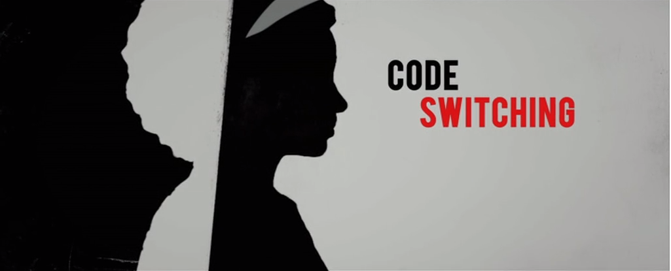

- Carefully watch the bonus material for the film titled “Code Switching”. You can find it in the main menu by selecting “Extras”. Write down notes on what code switching means.
- Code switching is a very common practice. Where do you experience it in your personal life? Discuss with a partner how your way of communicating changes in different situations and why.

- How does your experience with code switching differ or match with that of the people in the videoclip? Discuss in class how code switching can be connected to a person’s identity.

